
SOCIETY OF COUNTY
TREASURERS
President
Pete Moore

pete.moore@lincolnshire.gov.uk

SOCIETY OF DISTRICT
COUNCIL TREASURERS
President
Norma Atlay

Norma.atlay@north-herts.gov.uk


Matthew Style
Director, Local Government Finance & Settlement
Department for Communities and Local Government
2 Marsham Street
London
SW1P 4DF

Sarah Pickup
Deputy Chief Executive
Local Government Association
Smith Square
London
SW1P 3HZ

Chris Jackson
Head of Local Government Spending
HM Treasury
I Horse Guards Road
London
SW1A 2HQ

17 November 2016

Retention of Business Rates and the Two-Tier Split

Dear Matthew, Sarah and Chris,

This is a joint letter from the Society of County Treasurers (SCT) and the Society of District Council Treasurers (SDCT). Together, these authorities represent 46% of the population of England and provide services across 87% of its land area.

You will be aware from our joint letter of the 5 August 2016 that both societies have been seeking to work together where there may be areas of common interest or where we can try to seek a common consensus in relation to the future system for the retention of business rates. This of course includes the issue of the future split of the benefits and risks of business rate growth in two-tier areas. Whilst we are committed to arriving at a professional view on this, whether that is a continuation of the existing or an alternative split, we do believe there are a number of essential elements of the future system that we need to know prior to us forming such a judgement. We are particularly aware that we should address the question of what would be a fair split of rewards and risks. In particular, the key areas where we believe we would need a clearer steer or further information to inform the judgement would be the following:

- Information on the services or new responsibilities that are to be included in the quantum for transfer and where they will sit in terms of tiers.
- Proposals in respect of dealing with appeals.
- Proposals in respect of the operation of safety nets.
- Proposals in respect of resets, including frequency and what elements are covered if a partial reset.
- Proposals on the treatment of the inclusion or otherwise of devolution deals.

As stated above, we are committed to arriving at a view on an appropriate and fair split which balances risk and reward but, sequentially, it is essential we know the proposals in respect of the above areas first to be able to understand the new risk profile for each of us and therefore come to an evidenced based consensus of how these should be managed within the funding framework. To arrive at a suggested split without this information would be no more than a guess. We do not believe that a determination of a two-tier split is critical at this stage to the overall programme for BRR and can follow when proposals in respect of the above areas are firmed up. It would therefore be useful to understand the likely timescale in relation to these crucial pieces of information so that we can plan the next phase of the work.

We also wanted to take this opportunity to raise a couple of related issues.

Firstly, there are some ongoing concerns regarding the operation of the VOA and the resources available to deal with the appeals backlog. In particular, the need for greater accuracy, the speed of the processes and the challenge and transparency there is within the system (the vast majority of appeals are upheld with little influence or input from local government). We consider that incentivising accuracy and completion of the appeals backlog will be crucial to the delivery of a successful system and we would welcome a discussion with you on how the VOA can be incentivised to improve performance in this area which would enable a reduction in risk and volatility and better use of public funds.

Secondly, there are concerns about the ongoing uncertainty regarding the future treatment of health trusts and certain schools in respect of business rates charitable relief. The outcome of that uncertainty could lead to increased risks within any future system which would need to be managed and it could result in resources being transferred around one part of the public sector to another, which needs to be fully reflected in any future spending reviews and funding streams. It is also worth mentioning that the NHS action will presumably require commission to be paid to the firm leading the action potentially resulting in the NHS paying a large percentage success fee, therefore the public sector as a whole will lose resources. We feel the Government should intervene in this matter given the precedent this would set and the significant loss in public resources. There will be only one winner and it won't be the public sector.

We would, of course be happy to discuss any points we have made in this letter and are fully committed to supporting the collaborative work to continue to move towards a workable and flexible solution in respect of BRR.

Yours sincerely  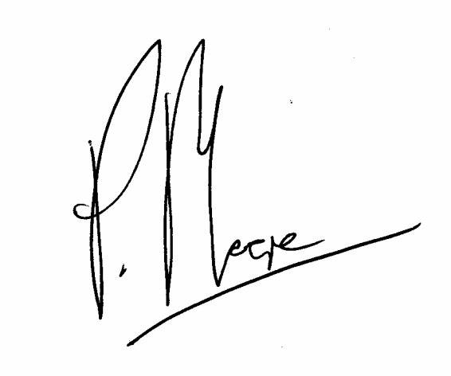  Pete Moore | 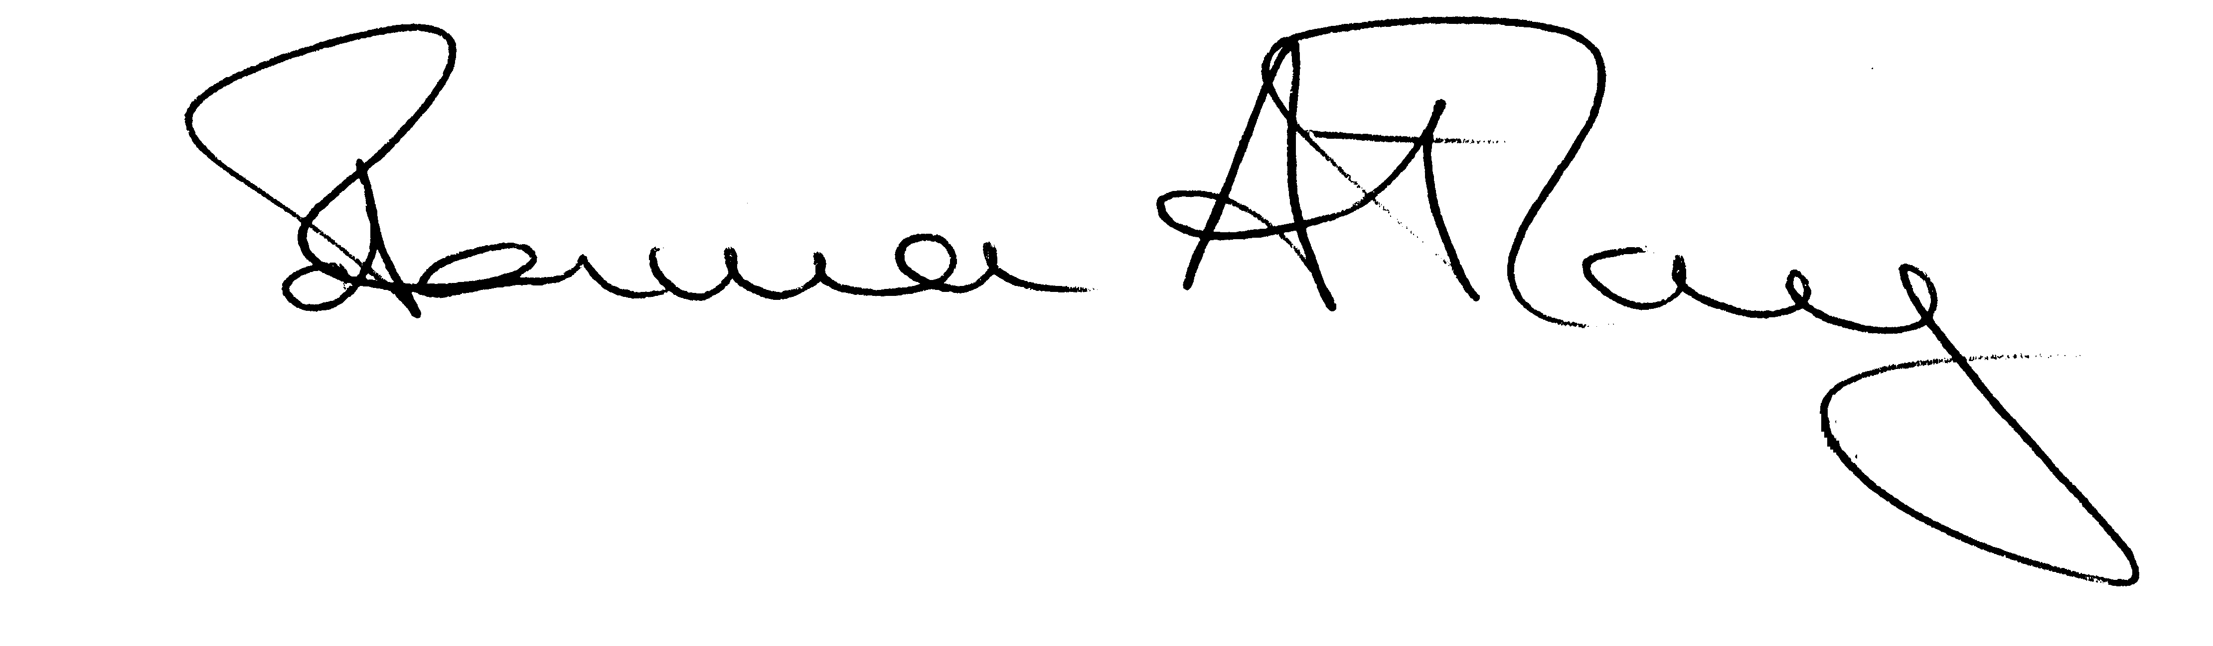  Norma Atlay
President | President
Society of County Treasurers | Society of District Council Treasurers

